Metamodeling of ANSYS-Calculated
Force Redistribution caused by Bolt Failures across a Plate
Manas Gupte † Sahil Mohamad † Clarence Worrell

Introduction
A simplified ANSYS model of a plate exposed to a spatially heterogeneous loading with 208 uniformly spaced bolts has been created to estimate the force at each location in the presence of bolt failures. Figure 1 is a simplified depiction of the plate and its coordinate system.
This study explores the potential for classical statistical modeling and machine learning to develop a metamodel approximation of the ANSYS model.
Figure 1: Simplified Illustration of Plate and Coordinate System

Sampling Strategy and Data Generation
A dataset consisting of 25,000 samples, each representing some combination of failed and intact bolts, was generated using three strategies. First, a batch of approximately 5,000 samples was generated using engineering judgment to represent small clusters of failed bolts. Next, 10,000 samples were generated via Monte-Carlo sampling with 15 as the maximum number of bolt failures for any given sample. Finally, 10,000 samples were generated via Monte-Carlo sampling with 50 as the maximum number of bolt failures for any given sample.
For each Monte-Carlo sample, first the number of failed bolts was sampled, and then then that number of failures was randomly assigned to specific locations. Figure 2 includes several selected samples to illustrate the range of postulated failures.
80% of the samples were selected randomly for model training, and the remaining 20% were reserved for model testing.

Figure 2: Selected Samples to Illustrate Range of Postulated Failures

Exploratory Data Analysis
The input data consist of 208 predictor variables, each representing the bolt state at a given location. The output data consist of 208 response variables, each representing the force at a given bolt location. The bolt location coordinate system is specified as r#c#. For example r3c5 refers to the bolt at Row 3, Column 5. Table 1 and Table 2 characterize the input and output data structure.

Table 1: Raw Input Data Structure
 | r1c1 | r2c1 | r3c1 | … | r8c26
Sample 1 | 0 | 0 | 0 | … | 0
Sample 2 | 1 | 0 | 0 | … | 0
Sample 3 | 0 | 0 | 1 | … | 0
. | . | . | . | … | .
. | . | . | . | … | .
. | . | . | . | … | .
Sample 25,000 | 0 | 1 | 0 | … | 1

Table 2: Raw Output Data Structure
 | r1c1 | r2c1 | r3c1 | … | r8c26
Sample 1 | 2.34 | 3.90 | 3.30 | … | 1.18
Sample 2 | 0.00 | 5.48 | 3.31 | … | 1.57
Sample 3 | 2.32 | 4.10 | 0.00 | … | 1.23
. | . | . | . | … | .
. | . | . | . | … | .
. | . | . | . | … | .
Sample 25,000 | 2.82 | 0.00 | 3.63 | … | 1.00

Figure 3 is a correlation plot of ANSYS-estimated bolt forces for a neighborhood of 50 bolt locations. The plot identifies various pairs of moderately correlated locations. Each correlated pair represents two immediately adjacent bolt locations. This indicates that the forces observed at any given location are largely a function of the immediately adjacent locations, and the influence of distant locations is weak, or even non-existent.
Also note that the correlation is negative. This is because the force at a broken bolt location is near zero, and the force at its neighbors increases because it is absorbing the force that the broken bolt had absorbed when it was intact. So when a bolt breaks, the force at its location decreases while the force at its neighbors increases.
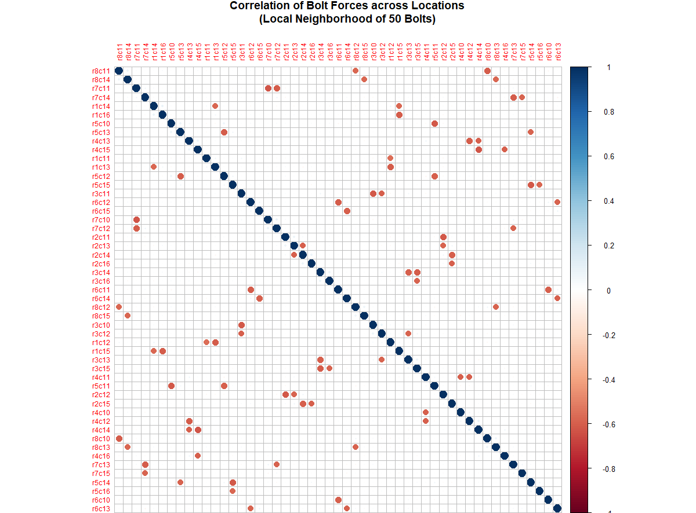
Figure 3: Correlation Plot of Bolt Forces at a Neighborhood of 50 Bolts

Figure 4 depicts histograms of the forces across one example row and one example column. The figure identifies that the range of forces is between zero (0) and 15. There also appears to be more variation in the vertical (columnar) direction than in the horizontal (row-wise) direction.
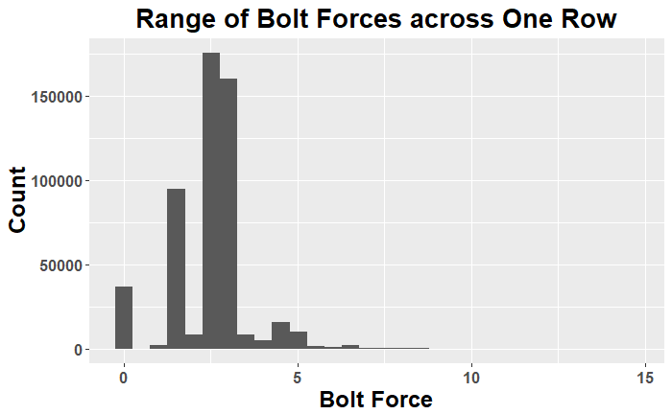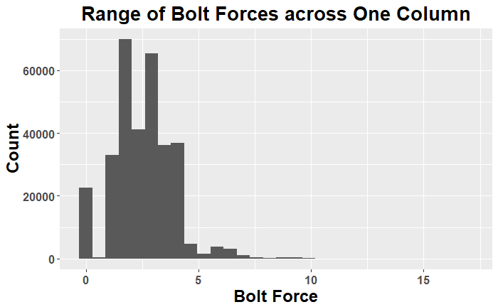
Figure 4: Histograms of the Forces across One Example Row and One Example Column

Data Pre-Processing
The data in their raw form present at least two challenges:
- High dimensionality
- Binary (0/1) nature of the predictors
The high dimensionality (208 predictors and 208 responses) makes it infeasible to perform a full grid sampling study. Strong symmetry between Columns 1-13 and 14-26 was noted however during exploratory data analysis, and this allowed rearranging the data to double the sample size from 25,000 to 50,000 samples, with each sample containing 104 bolt locations.
While 50,000 samples for 104 predictors is still far from an ideal full grid, the correlation plots generated during exploratory data analysis identified that the forces observed at any given location appear most influenced by its immediately adjacent neighbors. Subsequent modeling efforts may therefore focus on a local neighborhood surrounding the location to be predicted.
The binary (zero/one; in-tact/failed) nature of the predictors significantly challenged early model fitting efforts. The input data were therefore transformed such that the:
- Predictor variable each in-tact location was made to be the force observed at that location in the base case of zero failures.
- Predictor variable at each failed location was changed from zero to an arbitrarily large number (100) to distinguish it from the in-tact locations
This approach informs the predictor data with the known base case force distribution across the plate. It also makes the predictor data continuous instead of binary. Table 3 characterize the resulting pre-processed input data structure.
Table 3: Pre-Processed Input Data Structure
 | r1c1 | r2c1 | r3c1 | … | r8c13
Sample 1 | 2.34 | 3.90 | 3.30 | … | 1.18
Sample 2 | 100 | 3.90 | 3.30 | … | 1.18
Sample 3 | 2.34 | 3.90 | 100 | … | 1.18
. | . | . | . | … | .
. | . | . | . | … | .
. | . | . | . | … | .
Sample 50,000 | 2.34 | 0.00 | 3.30 | … | 1.18

Multiple Linear Regression
Multiple linear regression was first attempted using all 104 locations as predictor variables and the ANSYS-estimated force at one location as the response variable. The location at Row 4 Column 6 is roughly in the center of the plate and was selected for the prediction.
The caret package of R was used to implement lm with 10-fold cross as follows:
ctrl=trainControl(method="cv", number=10)
modelLinear<-train(x.train[], y.train[,44], method="lm", trControl = ctrl)

Figure 5 is a histogram of the resulting model coefficients for the linear model. The vast majority of coefficient values is near zero (0) indicating that those parameters individually contribute negligibly to the forces observed at the selected location.
The coefficient of about negative three (-3) is the failed bolt itself. There are two (2) coefficients with values near 1.75, and these represent the two bolts immediately and horizontally adjacent to the failed location.
Finally the model intercept is about 2.5, and this in theory would represent the force at the selected location should all bolts be failed. However, this intercept is not physically meaningful due to the poor overall fit of the linear model. In addition there were no samples involving more than 50 bolt failures, and so the all-failed estimation by the intercept is not well-trained.

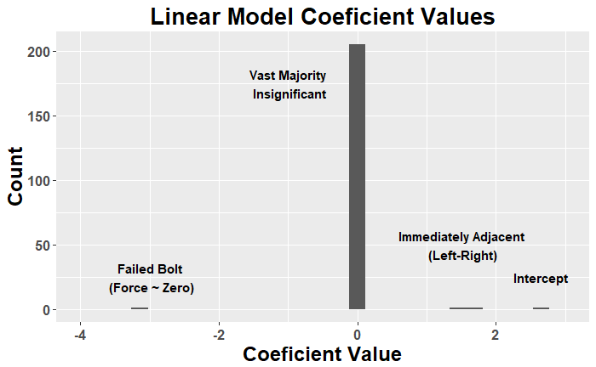
Figure 5: Histogram of Model Coefficient Values for Linear Model

Figure 6 plots the “observed” (ANSYS-calculated) bolt forces versus those predicted by the trained linear regression model. The linear regression seems to capture some of the trend at a gross level; however it is clearly a poor model for this application. The likely explanation is that the physics of force redistribution is highly non-linear.
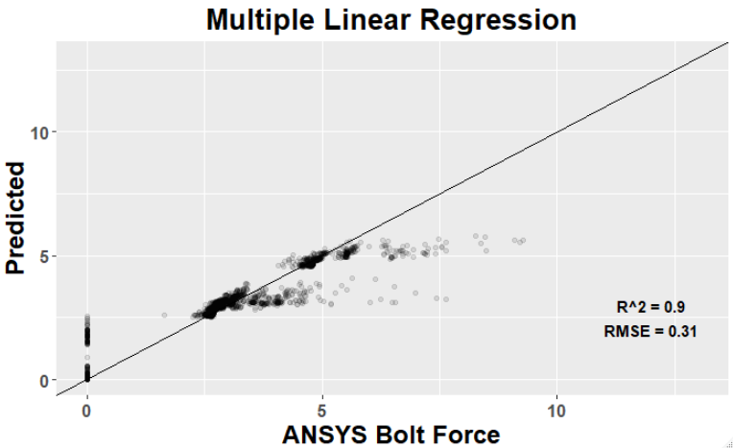
Figure 6: Observed (ANSYS-Calculated) versus Predicted

Figure 7 plots the residuals for the trained linear regression model. The residuals are clearly not Gaussian, reaffirming that linear regression is a poor model type for this application. The two distinct groups are likely associated with samples where 1) there are no failures in the local neighborhood, and 2) where there are failures in the local neighborhood. The negatively sloped 45° line is believed to represent cases where the predicted location (Row 4 Column 6) itself is failed.

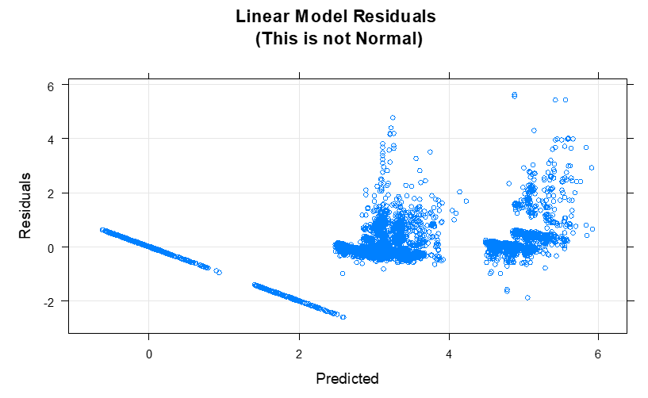
Figure 7: Residuals for Trained Linear Regression Model

Regularized Regression
Lasso, ridge, elastic net models were trained with 10-fold cross validation using the glmnet package of R. The mean squared error of each trained model is a follows:
- MSE_{ridge} = 4.9
- MSE_{elastic} = 5.7
- MSE_{lasso} = 5.3
The response variables range in general from 0 to 7, and so the above mean squared errors indicate poor fit similar to the multiple linear regression models. This again is likely due to the physics of force redistribution being non-linear
Next the significance of each model coefficient was categorized using a 1% threshold. Figure 8 depicts this classification and indicates that locations immediately adjacent to the predicted location (x=11, y=2) are most significant, and all other locations are insignificant.

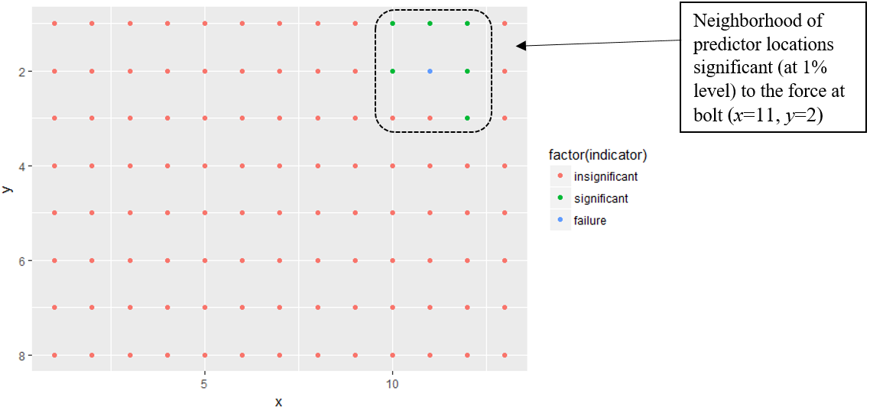
Figure 8: Significance Classification (using 1% Threshold) of each Bolt Location

k-Nearest Neighbors
k-Nearest Neighbors was tested using (x=4, y=6) as the location to be predicted. The caret package of R was used to implement kNN with 10-fold cross validation over a tuning parameter-space of k = 1:30 as follows:
ctrl=trainControl(method="cv", number=10)
modelKNN<-train(x=x.train[1:10000,], y=y.train[1:10000,44], method="knn",
preProc=c("center","scale"), tuneGrid=data.frame(.k=1:30), trControl=ctrl)

Figure 8 plots the cross-validated model accuracy (measured by RMSE) for a range of model complexities between k = 1 and k = 30 neighbors. This plot indicates the optimal (lowest RMSE) kNN model to have seven (7) neighbors.
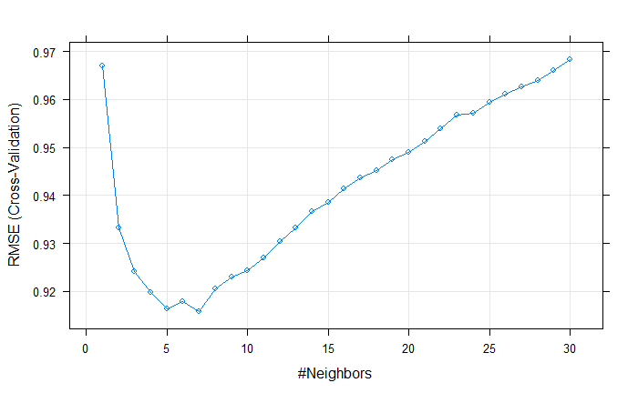
Figure 8: kNN RMSE over Range of Neighbors used for Model Training

Figure 9 plots the observed (ANSYS-calculated) versus predicted by the k = 7 kNN model. The model struggles to reflect any of the observed variation. This poor performance may be related to inadequate sample size. The exploratory data analysis and the linear models identified that the force at any one location is largely driven by status of the immediately adjacent locations. When the kNN model is trained to predict force at one location, in this case (x=4, y=6), there are likely not enough samples involving variation immediately surrounding to that location to adequately train the model. The vast majority of samples that have variation distant from the location of interest are largely “wasted” and may impose noise onto the learning process.
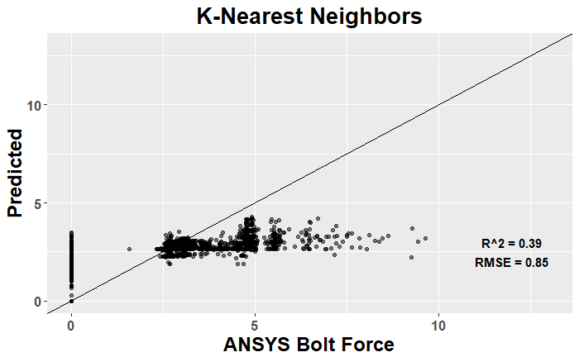
Figure 9: Observed (ANSYS-Calculated) versus Predicted

Given the kNN challenges with insufficient sample size relative to the high dimensionality, and insights from the linear models that conditions at only the adjacent bolts are significant, it may be worth:
- Reshaping the training data such the response at any one location is a function only of the eight (8) immediately adjacent neighbors to any one bolt location to be predicted.

Kriging
Kriging was tested using the gstat package of R, which is commonly used for two dimensional interpolation problems, such as the gold mine predictions for which the method was originally developed by Daniel Krige. The basic R coding is summarized as follows:
forces.vgm <- variogram(force~1, krigSample)
forces.fit <- fit.variogram(forces.vgm, model=vgm(1, "Ste", 1))
plate.kriged <- krige(force ~ 1, krigSample, plate.grid, model=forces.fit)

Three Kriging models were trained, and the results are visualized in Figures 10-12.
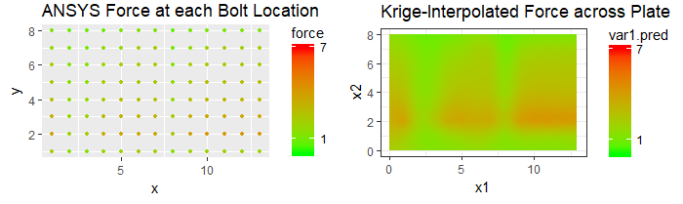
Figure 10: Predict Forces between all Bolt Locations, with No Failed Bolts, and the Forces at all Bolts Known

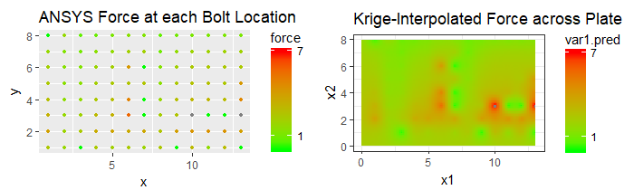
Figure 11: Predict Forces between all Bolt Locations, Given a Random Sample of Nine (9) Failed Bolts, and the Forces at all Bolts Known

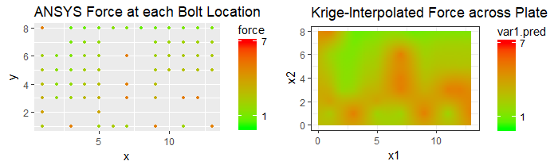
Figure 12: Predict Forces at the 34 Locations Immediately Adjacent to the Nine (9) Failed Bolts Given the Forces at all Bolt Locations except the 34 Adjacent to Failures

The predictions of Figure 11 and 12 are of the same sample involving nine (9) failed bolts. However, in Figure 11 the model was trained with the force at all bolt locations known, and so the Kriging prediction is essentially an interpolation between known values. The predicted heat map is likely close to the true heat map. In Figure 12, Kriging is predicting forces at bolt locations surrounding the failures (not simply interpolating between known forces at each location).
Note one distinction between the figures is that in Figure 11, the failures are shown as bright green circles indicating zero force, which is the form of the raw ANSYS output data. In Figure 12, the failed locations have been changed to a value of five (5) to make the Kriging interpolation more realistic, since interpolating to a value of zero would erroneously indicate low forces surrounding each failure.
Comparing Figure 11 and Figure 12, Kriging performed reasonably well. There is some over-estimation in Figure 12, and this is likely due choosing a value of five (5) to represent the force at each failed bolt location. The Kriging model could tuned by adjusting this value.

Principal Component Analysis (PCA) and Artificial Neural Network (ANN)
First, countourf() plots of correlation within the input and output data were generated, and these plots are shown in Figure 13 and Figure 14, respectively.
Figure 13: contourf() Correlation Plot of Input Space
Figure 13 indicates essentially zero correlation within the input space, which is sensible given the input space simply indicates where randomly selected bolt failure locations exist for each sample.
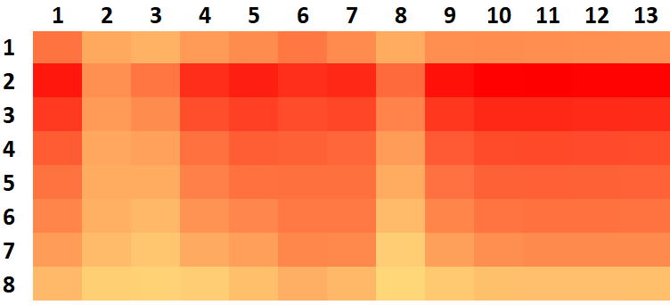
Figure 14: contourf () Correlation Plot of Output Space (Left) and Sample Heat Map (Right)

The left panel of Figure 14 similarly indicates near-zero output space correlation across most of the plate. However, there are two distinct and discontinuous lines of strong negative correlation parallel to the diagonal.
These lines are offset by exactly eight (8) index locations from the diagonal, which corresponds to the two bolts horizontally adjacent to each failed bolt location. The negative correlation indicates that when a failure occurs, the force absorbed at that location decreases to zero, while the forces absorbed at the adjacent locations increase. Bolts further than the immediately adjacent locations show no change.
The discontinuous character of the two parallel lines of negative correlation is a feature of the plate design that can be seen in the right panel of Figure 14. The right panel is a heat map of forces at each location assuming no bolt failures. The discontinuities at Columns 2-3 and 8 correspond to the discontinuities in the countourf() plot, and these are sections of the plate design that are known to have little influence on the adjacent portions of the plate, because of their configuration. The left panel indicates a third discontinuity near the 40th index, but this is not as clear in the heat map.
Next, PCA was applied to the response data using the pca() function of MATLAB 2015b. Figure 15 plots the cumulative percent of variance explained as a function of the number of scores retained. The plot indicates 50 scores would need to be retained to explain 90% of the variance, which would represent a ~50% dimensionality reduction.
Figure 15: Cumulative Variance Explained by PCA Score

Finally, an artificial neural network as developed using the MATLAB Machine Learning Toolbox (nnfit). As a first attempt, all 104 predictor variables were fitted to 32 response PCA scores, which explains 75% of the response data. A default neural network with one hidden layer containing 10 neurons was fitted using Levenberg-Marquardt back propagation. 70% of the data was used for training, 15% for validation, and 15% for testing.
The ANN trained for six (6) hours without converging, and inspection of the performance plot (Figure 16 below) suggested the model had converged but that it would not achieve the minimum error required for the training to terminate.
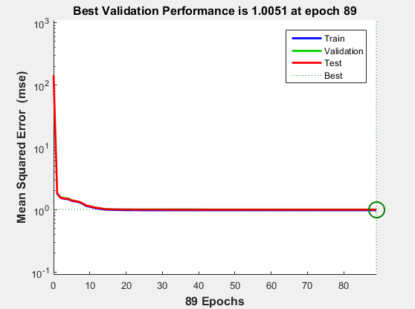
Figure 15: ANN Training Performance

The model training was terminated and the workspace saved. Figure 16 depicts the observed versus predicted for the trained ANN model.
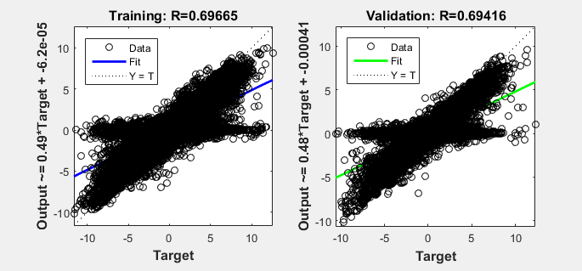
Figure 16: ANN Observed versus Predicted

Figure 16 indicates a relatively poor fit (correlation, R, between observed and predicted of ~70%). However, inspecting the plot indicates the bulk of predicted data do align with the observations, but that a horizontally oriented subset of data skews the fit off-diagonal, clockwise. This horizontal data occurs when the prediction is zero (0), which is likely related to the failed bolt locations being identified as a zero (0) in the predictor data.
The trained ANN was then used to predict the responses for all samples. It is acknowledged that this includes all of the data upon which the ANN was trained. First, the PCA scores were predicted by the trained ANN, and the scores were transformed back into the original data space by multiplying the scores and eigenvectors, using the following code:
predictedScores = net(predictors');
predictedScores = predictedScores';
predicted = predictedScores * pcaRESP.coeff(1:32,:);

Figure 17 plots the observed responses versus those predicted by the PCA and ANN.
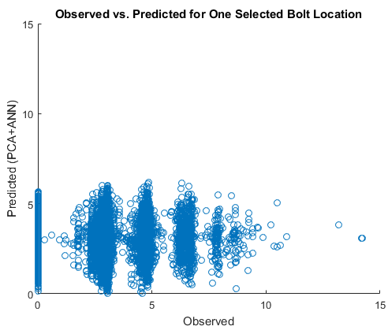
Figure 17: Observed vs. Predicted for One Selected Bolt Location
Figure 17 indicates the PCA and ANN was unable to predict the observations with reasonable accuracy. This in part is because the model fitting process included the following two known degradations:
- Only enough PCA scores were retained to explain 75% of the variation. This was done to manage the dimensionality for ANN training feasibility.

- The ANN achieved only a R = 0.60 correlation between observed and predicted.

Figure 17 also illustrates the discrete nature of the response. There are five (5) distinct groupings of response data, likely corresponding to the range of nearby bolt failures postulated in the input space. It is possible this characteristic could be used to generate a very simple model, perhaps one that is directly proportional to the number of immediately adjacent bolt failures.

Alternate Formatting of Input Data
Finally, given that all of the attempted models have struggled with dimensionality, an alternate format of the input data was developed. The new input data table has 30 columns, with each pair of columns ([1,2], [3,4], [5,6], etc.) corresponding to the coordinate locations of each failed bolt. All samples with more than 15 bolt failures were truncated from the input space, leaving ~45,000 samples available for modeling.
Table 4 illustrates the alternate data format. For example, Sample 1 has one failed bolt at position (X=2, Y=2). Sample 2 has failed bolts at positions (X=5, Y=3) and (X=2, Y=8). Sample 3 has 15 failed bolt locations.
 | X₁ | Y₁ | X₂ | Y₂ | X₃ | Y₃ | . | . | . | X₃₀ | Y₃₀
Sample 1 | 2 | 2 | 0 | 0 | 0 | 0 | . | . | . | 0 | 0
Sample 2 | 5 | 3 | 2 | 8 | 0 | 0 | . | . | . | 0 | 0
Sample 3 | 1 | 6 | 5 | 3 | 12 | 3 | . | . | . | 6 | 6
. | . | . | . | . | . | . | . | . | . | . | .
. | . | . | . | . | . | . | . | . | . | . | .
. | . | . | . | . | . | . | . | . | . | . | .

Initial model fitting using the alternate input data format struggled to predict with reasonable accuracy. The primary reason is suspected to be that the output data are not similarly indexed. The output data are indexed 1:104; whereas this alternate input data format are indexed by X and Y position. It is also possible that the models interpret X_{n} and Y_{n} as separate predictors, but in reality they are related because these two parameters indicate the position of one bolt.

Conclusion

Appendix A: R Coding
###Load Libraries
```{r eval=TRUE, message=FALSE, warning=FALSE}
library(AppliedPredictiveModeling)
library(caret)
library(corrplot)
library(dplyr)
library(ggplot2)
library(glmnet)
library(gridExtra)
library(gstat)
library(Lahman)
library(magrittr)
library(nnet)
library(scales)
library(sp)
library(stats)
library(tidyr)
```

###Import and Pre-Process Data
```{r eval=TRUE}
predictors<-read.table("_predictors.csv",header=TRUE,sep=",",dec=".")
responses<-read.table("_responses.csv",header=TRUE,sep=",",dec=".")
predictors<-predictors[,1:105]
responses<-responses[,1:105]
#Replace all zero (failed) locations with large number.
predictors[predictors==0]<-100
predictors=predictors[,2:105]
responses=responses[,2:105]
```

###Split into Training (80%) and Test (20%) Data
```{r eval=TRUE}
indices = sample(1:nrow(predictors), size=0.2*nrow(predictors))
x.test = predictors[indices,]
x.train = predictors[-indices,]
y.test = responses[indices,]
y.train = responses[-indices,]
rm(indices, predictors, responses)
```

###Exploratory Data Analysis
```{r eval=TRUE}
corrplot(cor(y.train[,1:50]),order="hclust",tl.cex = 0.75,title="Correlation of Bolt Forces across Locations\n(Local Neighborhood of 50 Bolts)",mar = c(0,0,2,0))

oneCol<-data.frame(c(y.train[,97],y.train[,98],y.train[,99],y.train[,100],
y.train[,101],y.train[,102],y.train[,103],y.train[,104]))
oneRow<-data.frame(c(y.train[,4],y.train[,12],y.train[,20],y.train[,28],y.train[,36],
y.train[,44],y.train[,52],y.train[,60],y.train[,68],y.train[,76],
y.train[,84],y.train[,92],y.train[,100]))

ggplot(data=oneRow, aes(x=oneRow[,1]))+
geom_histogram()+
ggtitle("Range of Bolt Forces across One Row")+
xlab("Bolt Force")+
ylab("Count")+
theme(axis.title = element_text(face="bold",size = 18))+
theme(axis.text = element_text(face="bold",size=12))+
theme(plot.title = element_text(hjust = 0.5,face="bold",size = 20))

ggplot(data=oneCol, aes(x=oneCol[,1]))+
geom_histogram()+
ggtitle("Range of Bolt Forces across One Column")+
xlab("Bolt Force")+
ylab("Count")+
theme(axis.title = element_text(face="bold",size = 18))+
theme(axis.text = element_text(face="bold",size=12))+
theme(plot.title = element_text(hjust = 0.5,face="bold",size = 20))

rm(oneCol,oneRow)
```

###Linear Regression
```{r, message=FALSE, warning=FALSE}
ctrl=trainControl(method="cv", number=10)
modelLinear<-train(x.train[], y.train[,44], method="lm", trControl = ctrl)

predictLinear<-x.test
predictLinear$predicted<-predict(modelLinear,predictLinear)
predictLinear$observed<-data.frame(y.test[,44])

ObsFit<-data.frame(predictLinear$observed,predictLinear$predicted)
names(ObsFit) <- c("obs", "pred")
modelstats=defaultSummary(ObsFit)
RMSE=round(modelstats[1],2)
Rsq=round(modelstats[2],2)

ggplot(data=predictLinear, aes(x=observed,y=predicted))+
geom_point(alpha=0.1)+
geom_abline(intercept = 0,slope = 1)+
ggtitle("Multiple Linear Regression")+
xlim(0,13)+
ylim(0,13)+
xlab("ANSYS Bolt Force")+
ylab("Predicted")+
theme(axis.title = element_text(face="bold",size = 18))+
theme(axis.text = element_text(face="bold",size=12))+
theme(plot.title = element_text(hjust = 0.5,face="bold",size = 20))+
annotate("text",x=12,y=3,label = paste("R^2 =",Rsq),fontface=2,size=4)+
annotate("text",x=12,y=2,label = paste("RMSE =",RMSE),fontface=2,size=4)

xyplot(resid(modelLinear) ~ predict(modelLinear),
type = c("p","g"),
xlab = "Predicted", ylab = "Residuals",
main = "Linear Model Residuals\n (This is not Normal)")

coef<-as.data.frame(coef(modelLinear$finalModel))
coefSignificant<-data.frame(summary(modelLinear)$coef[summary(modelLinear)$coef[,4] <= 0.05, 4])

ggplot(data=coef, aes(x=coef(modelLinear$finalModel)))+
geom_histogram()+
ggtitle("Linear Model Coeficient Values")+
#xlim(-4,3)+
xlab("Coeficient Value")+
ylab("Count")+
theme(axis.title = element_text(face="bold",size = 18))+
theme(axis.text = element_text(face="bold",size=12))+
theme(plot.title = element_text(hjust = 0.5,face="bold",size = 20))+
annotate("text",x=2.65,y=25,label="Intercept",fontface=2,size=4)+
annotate("text",x=1.5,y=50,label="Immediately Adjacent\n (Left-Right)",fontface=2,size=4)+
annotate("text",x=-1.0,y=175,label="Vast Majority\n Insignificant",fontface=2,size=4)+
annotate("text",x=-3,y=25,label="Failed Bolt\n (Force ~ Zero)",fontface=2,size=4)

rm(coef,coefSignificant,ctrl,modelstats,RMSE,Rsq,ObsFit,modelLinear,predictLinear)
```

###Regularized Regression
```{r}
# Fit models
failure<-"r2c11"
predictors<-read.csv("_predictors.csv")
responses<-read.csv("_responses.csv")
predictors<-predictors[,-1]
responses<-responses[,-1]
responses<-responses[,1:104]

sam <- sample(1:nrow(predictors),floor(0.8*nrow(predictors)))
train.x <- as.matrix(predictors[sam,])
train.y <- as.matrix(responses[sam,failure])
test.y <- as.matrix(predictors[-sam,failure])
test.x <- as.matrix(responses[-sam,])
fit.ordinary <- lm(train.y ~ train.x)
hist(length(fit.ordinary$coefficients))
fit.lasso <- glmnet(train.x, train.y, family="gaussian", alpha=1)
dev.new(); hist(fit.lasso$df)
fit.ridge <- glmnet(train.x, train.y, family="gaussian", alpha=0)
dev.new(); hist(fit.ridge$df)
fit.elnet <- glmnet(train.x, train.y, family="gaussian", alpha=.5)
dev.new(); hist(fit.elnet$df,breaks=c(10:200:10))
#
# 10-fold cross validation for each alpha (ranging between Ridge Regression and Lasso across the Elastic Net)
#
for (i in 0:10) {
assign(paste("fit", i, sep=""), cv.glmnet(train.x, train.y, type.measure="mse", alpha=i/10,family="gaussian"))
}
#
# Plot solution paths (to choose regularized models within each "family")
#
dev.new()
par(mfrow=c(1,2))
plot(fit10)
grid()
plot(fit.lasso, xvar="lambda")
#
dev.new()
par(mfrow=c(1,2))
plot(fit0)
grid()
plot(fit.ridge, xvar="lambda")
#
dev.new()
par(mfrow=c(1,2))
plot(fit5)
grid()
plot(fit.elnet, xvar="lambda")
#
# Calculating MSE for each ALPHA
#
yhat0 <- predict(fit0, s=fit0$lambda.1se, newx=test.x)
yhat1 <- predict(fit1, s=fit1$lambda.1se, newx=test.x)
yhat2 <- predict(fit2, s=fit2$lambda.1se, newx=test.x)
yhat3 <- predict(fit3, s=fit3$lambda.1se, newx=test.x)
yhat4 <- predict(fit4, s=fit4$lambda.1se, newx=test.x)
yhat5 <- predict(fit5, s=fit5$lambda.1se, newx=test.x)
yhat6 <- predict(fit6, s=fit6$lambda.1se, newx=test.x)
yhat7 <- predict(fit7, s=fit7$lambda.1se, newx=test.x)
yhat8 <- predict(fit8, s=fit8$lambda.1se, newx=test.x)
yhat9 <- predict(fit9, s=fit9$lambda.1se, newx=test.x)
yhat10 <- predict(fit10, s=fit10$lambda.1se, newx=test.x)

mse0 <- mean((test.y - yhat0)^2)
mse1 <- mean((test.y - yhat1)^2)
mse2 <- mean((test.y - yhat2)^2)
mse3 <- mean((test.y - yhat3)^2)
mse4 <- mean((test.y - yhat4)^2)
mse5 <- mean((test.y - yhat5)^2)
mse6 <- mean((test.y - yhat6)^2)
mse7 <- mean((test.y - yhat7)^2)
mse8 <- mean((test.y - yhat8)^2)
mse9 <- mean((test.y - yhat9)^2)
mse10 <- mean((test.y - yhat10)^2)

print(paste0("MSE for Ridge: ", mse0))
print(paste0("MSE for Elastic Net:",mse5))
print(paste0("MSE for Lasso:", mse10))

coeff_ridge<-coef(fit0,s='lambda.min')
coeff_elastic<-coef(fit5,s='lambda.min')
coeff_lasso<-coef(fit10,s='lambda.min')
sig_coeff_ridge<-as.matrix(coeff_ridge[which(abs(coeff_ridge)>=.01),])
sig_coeff_elastic<-as.matrix(coeff_elastic[which(abs(coeff_elastic)>=.01),])
sig_coeff_lasso<-as.matrix(coeff_lasso[which(abs(coeff_lasso)>=.01),])

viz_grid<-function(coeff,failure){

a = as.data.frame(expand.grid(1:13,1:8))
colnames(a) = c('x', 'y')
b<-strsplit(row.names(coeff),"[a-z]+")
matrix<-as.matrix(coeff)
x.c<-rep(0,length(matrix))
y.c<-rep(0,length(matrix))
for(i in 2:length(matrix)){
x.c[i]<-as.numeric(b[[i]][3])
y.c[i]<-as.numeric(b[[i]][2])
}
x.c<-x.c[-1]
y.c<-y.c[-1]
sigbolts<-as.data.frame(cbind(x.c,y.c)) #contains the coordinates
a$indicator<-0

for (i in 1:length(sigbolts[,2])){

for(j in 1:length(a[,2])){

if(sigbolts[i,1]==a[j,1] & sigbolts[i,2]==a[j,2])
a[j,3]<-1
}
}
fail<-strsplit(failure,"[a-z]+")
index<-which(a$x==fail[[1]][3] & a$y==fail[[1]][2])
a[index,3]<-2
ggplot() + geom_point(data = a, aes(x = x, y = y,color=factor(indicator))) + geom_point() + scale_y_continuous(trans='reverse') + scale_color_discrete(label=c("insignificant","significant","failure"))
}

viz_grid(sig_coeff_ridge,failure)
viz_grid(sig_coeff_elastic,failure)
viz_grid(sig_coeff_lasso,failure)

rm(predictors,responses,test.x,test.y,train.x,train.y)
rm(sig_coeff_elastic,sig_coeff_lasso,sig_coeff_ridge)
rm(yhat0,yhat1,yhat2,yhat3,yhat4,yhat5,yhat6,yhat7,yhat8,yhat9,yhat10)
rm(coeff_elastic,coeff_lasso,coeff_ridge)
rm(failure,fit.elnet,fit.lasso,fit.ordinary,fit.ridge)
rm(fit0,fit1,fit2,fit3,fit4,fit5,fit6,fit7,fit8,fit9,fit10,i)
rm(mse0,mse1,mse2,mse3,mse4,mse5,mse6,mse7,mse8,mse9,mse10)
rm(sam,viz_grid)
```

###K-Nearest Neighbors
```{r eval=TRUE}
ctrl=trainControl(method="cv", number=2)
modelKNN<-train(x=x.train[1:5000,], y=y.train[1:5000,44], method="knn", preProc=c("center","scale"), tuneGrid=data.frame(.k=1:30), trControl=ctrl)
print(modelKNN)
plot(modelKNN)

predictKNN<-x.test
predictKNN$predicted<-predict(modelKNN,predictKNN)
predictKNN$observed<-data.frame(y.test[,44])

ObsFit<-data.frame(predictKNN$observed,predictKNN$predicted)
names(ObsFit) <- c("obs", "pred")
modelstats=defaultSummary(ObsFit)
RMSE=round(modelstats[1],2)
Rsq=round(modelstats[2],2)

ggplot(data=predictKNN, aes(x=observed,y=predicted))+
geom_point(alpha=0.5)+
geom_abline(intercept = 0,slope = 1)+
ggtitle("K-Nearest Neighbors")+
xlim(0,13)+
ylim(0,13)+
xlab("ANSYS Bolt Force")+
ylab("Predicted")+
theme(axis.title = element_text(face="bold",size = 18))+
theme(axis.text = element_text(face="bold",size=12))+
theme(plot.title = element_text(hjust = 0.5,face="bold",size = 20))+
annotate("text",x=12,y=3,label = paste("R^2 =",Rsq),fontface=2,size=4)+
annotate("text",x=12,y=2,label = paste("RMSE =",RMSE),fontface=2,size=4)
```

###Kriging
```{r eval=TRUE}

for (i in 3:5){

krigSample<-read.table("_krigingData.csv",header=TRUE,sep=",",dec=".")
krigSample<-krigSample[,c(1,2,i)]
krigSample<-na.omit(krigSample)
colnames(krigSample) <- c("x", "y", "force")
coordinates(krigSample) <- ~ x + y
class(krigSample)

krigSample %>% as.data.frame %>%
ggplot(aes(x, y)) + geom_point(aes(color=force,size=force)) +
scale_colour_gradient(low = "green", high = "red")+
ggtitle("Bolt Force at each Location") + coord_equal()

forces.vgm <- variogram(force~1, krigSample)
forces.fit <- fit.variogram(forces.vgm, model=vgm(1, "Ste", 1))
plot(forces.vgm,forces.fit)

Sr1 = Polygon(cbind(c(0,0,13,13),c(0,8,8,0)))
Srs1 = Polygons(list(Sr1), "s1")
SpP=SpatialPolygons(list(Srs1))
plate.grid=spsample(SpP,10000,"regular")

plate.kriged <- krige(force ~ 1, krigSample, plate.grid, model=forces.fit)

plot1 <- krigSample %>% as.data.frame %>%
ggplot(aes(x, y)) + geom_point(aes(color=force),size=1) +
scale_colour_gradient(low = "green", high = "red", breaks=c(1,7), labels=c(1,7), limits=c(0,7))+
ggtitle("ANSYS Force at each Bolt Location") + coord_equal()

plot2 <- plate.kriged %>% as.data.frame %>%
ggplot(aes(x=x1, y=x2)) + geom_tile(aes(fill=var1.pred)) + coord_equal() +
scale_fill_gradient(low = "green", high="red", breaks=c(1,7), labels=c(1,7), limits=c(0,7)) +
scale_x_continuous(labels=comma) + scale_y_continuous(labels=comma) +
theme_bw() + ggtitle("Krige-Interpolated Force across Plate")

grid.arrange(plot1, plot2, ncol = 2)
}
```

Appendix B: MATLAB 2015b Coding
%% INITIALIZE AND IMPORT DATA
clc; clear all; close all;
set(0,'defaultfigurecolor',[1 1 1]);
cd ('C:\Users\worrelcl\Desktop\Clarence\IE2065 (Stat Analysis & Optimization)\Project');
predictors = csvread('_predictors.csv', 1, 1); predictors = predictors(:,1:104);
responses = csvread('_responses.csv', 1, 1); responses = responses(:,1:104);
numSamples = length(predictors);
pcaPRED = struct('original', predictors);
pcaRESP = struct('original', responses);

%% PRE-PROCESS DATA FROM 104 COLUMNS TO 30 COLUMNS
% where each pair of columns identify the X,Y coordinates of each failed
% bolt location. Truncate samples with more than 15 bolt failures.

% First, count number of failures for each sample,
% identify samples with <=15 failures, and
% truncate predictor/response data to samples with <=15 failures
numFailed = zeros(numSamples,1);
counter = 1;
for sample = 1:numSamples
numFailed(sample,1) = sum(predictors(sample,:)==0);
if numFailed(sample,1) <= 15
keepIndex(counter,1) = sample;
counter = counter + 1;
end
end
predictors = predictors(keepIndex,:);
responses = responses(keepIndex,:);
numSamples = length(predictors);

% Next, get X,Y coordinates of each failure
failCols = zeros(numSamples,15);
for sample = 1:numSamples
counter = 1;
for col = 1:104
if predictors(sample,col)==0
failCols(sample,counter) = col;
counter = counter + 1;
end
end
end

% Finally, populate a new 30-column predictor matrix with X,Y location of
% each failed bolt
predictorsXY = zeros(numSamples,30);
for sample = 1:numSamples
counter = 0;
for col = 1:15
if failCols(sample,col) > 0
counter = counter + 1;
failedColIndex = failCols(sample,col);
predictorsXY(sample,2*counter-1) = rem((failedColIndex-1),8)+1; %X coord;
predictorsXY(sample,2*counter) = floor((failedColIndex-1)/8)+1; %Y coord
end
end
end

clear col counter failedColIndex keepIndex sample

%% Correlation Plots
zPRED = zscore(pcaPRED.original);
cPRED = (zPRED'*zPRED) / (numSamples-1);
figure; contourf(cPRED), colorbar, title('Correlation between Predictor Variables');

zRESP = zscore(pcaRESP.original);
cRESP = (zRESP'*zRESP) / (numSamples-1);
figure; contourf(cRESP), colorbar, title('Correlation between Response Variables');

clear cPRED cRESP zPRED zRESP pcaPRED

%% PCA
[pcaRESP.coeff, pcaRESP.score, pcaRESP.latent, pcaRESP.tsquared, pcaRESP.explained] = pca(pcaRESP.original);

pcaRESP.explained=cumsum(pcaRESP.explained);
figure; bar(pcaRESP.explained), title('Cumulative Percent of Variance Explained'), xlabel('Score'), ylabel('Percent'), xlim([0,100]);

NNtargetPCA = pcaRESP.score(:,1:32);

predictedScores = net(predictors');
predictedScores = predictedScores';
predicted = predictedScores * pcaRESP.coeff(1:32,:);

boltLoc = 84;
figure; hold on
scatter(responses(:,boltLoc),predicted(:,boltLoc) + mean(responses(:,boltLoc)));
title('Observed vs. Predicted for One Selected Bolt Location');
xlabel('Observed');
ylabel('Predicted (PCA+ANN)');
xlim([0,15]);
ylim([0,15]);
hold off

